Multiple Linear Regression

🔹 1. What is Multiple Linear Regression?
Definition:
Multiple Linear Regression (MLR) is a supervised regression algorithm that predicts a continuous output variable based on two or more independent variables.
It generalizes simple linear regression by allowing the model to capture relationships in higher-dimensional feature spaces.

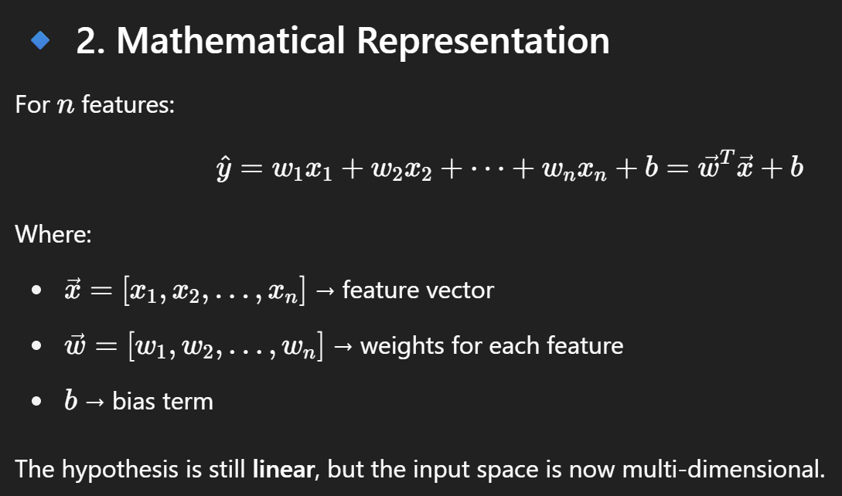
🔹 5. Assumptions of Multiple Linear Regression
Same as simple linear regression, but extended:
- Linearity: Relationship between dependent and independent variables is linear.
- Multivariate Normality: The features (and residuals) are normally distributed.
- No Multicollinearity: Independent variables are not strongly correlated.
🔹 8. When to Use MLR?
- When you want to explain/predict outcomes based on multiple features
- When there's no strong multicollinearity
- When residuals follow normality and homoscedasticity

